**NEA 2: ADOPT A SINGAPORE**

**Product Requirements and Specifications Document**

|  |  |
| --- | --- |
| Document ID |  |
| Version | Version 1.0 |
| Originator | Ram Bhamidi |
| Sign-Off Date |  |
| Status | Draft for Discussion |

Modification History:

|  |  |  |  |
| --- | --- | --- | --- |
| Version | Date | Author | Description |
| 1 | 22-July-13 | Ram Bhamidi | Draft for Discussion |

1. **INTRODUCTION**
   1. ***Business Objective / Purpose***
   2. ***Success Criteria***
   3. ***Users***

The app will be used by people in Singapore.

* 1. ***Devices***

Facebook - Web and Mobile (iOS, Android)

* 1. ***Product Overview***

We need to develop an app for the web and mobile versions. The app encourages people to keep Singapore clean

* 1. ***Campaign /Marketing Details***

Details of marketing campaign(s) the client is planning to run along with dates

* 1. ***Brand Guidelines***

There are no specific brand guidelines for the use of images and fonts

1. **HOSTING DETAILS**
   1. Web Application Server
      * The application will be hosted on Circus Social Server
      * Application would be running as

Final Web URL : http://apps.facebook.com/adoptasingapore

Testing URL : http://apps.facebook.com/adoptasingaporedev

* 1. Database Server
     + Use MySQL server for database
  2. Facebook App Details
     + Facebook App Name: SGX Stock Up
     + Facebook App URL: [http://apps.facebook.com/adoptasingapore](http://apps.facebook.com/sgxstockup)
     + Privacy Policy URL: [http://apps.circussocial.com/index.php?r= adoptasingapore /tab&by_tab=1](http://apps.circussocial.com/index.php?r=%20sgxstockup%20/tab&by_tab=1)
     + Terms and Condition: [http://apps.circussocial.com/index.php?r= adoptasingapore /tab&by_tab=2](http://apps.circussocial.com/index.php?r=%20sgxstockup%20/tab&by_tab=2)
     + Facebook tab Images:

111 x 74

90 x 90

* 1. Facebook Permissions
     + To share on a user’s wall.
     + Basic Profile Data

1. **FLOW DIAGRAM**
2. **GAME LOGIC**
   1. **Synopsis of game**

Player will attempt to clear all 18 levels of the game ( 17 visible levels + 1 hidden bonus level) in order to win the top place in the leaderboard.

* 1. **Character**

Player wants to keep his home clean, particularly the region he lives in. He is enthusiastic and strives to keep his city clean and green.

* 1. **Universe**

The island of Singapore, with 18 areas. In each area, one of three specific locations will need to be cleared of trash.

* HDB (Housing Development Board )
* Hawker Centre
* Public Park
  1. **Game element**

Users will proceed to more advanced levels with ***more trash*** to clear. The winner with the **most points** will win the game at the end of the campaign!

* 1. **Game Play**

The main function of the game:

1. Users click on a trash image during game play
2. Trash disappears immediately
3. Points are accumulated and updated after every level is cleared successfully
   1. **How can players earn points?**

* Players can earn points when they complete a level
  + Points earned in a level = Trash pieces in that level + 2* (Timer countdown - Time taken to complete the level). See Column G below
  + If a player does not complete a level, they do not earn any points for that level
* Players can earn 10 bonus points when they finish the whole game (level 18)
* Players can earn points when they invite their friends (FR8)

The area names and type have not been finalized and are subject to change. Note to developers: This data needs to be in the database and should be pulled in dynamically

|  |  |  |  |  |  |  |  |
| --- | --- | --- | --- | --- | --- | --- | --- |
| A | B | C | D | E | F | G |  |
| **Level** | **Area** | **Type** | **Trash Pieces** | **Timer**  **Countdown (s)** | **Time taken for user to complete (s)** | **Points Awarded** |  |
| 1 | Jurong | HDB | 10 | 10 | 10 | 10 |  |
| 2 | Lim Chu Kang | HC | 11 | 10 | 8 | 15 |  |
| 3 | Choa Chu Kang | HC | 12 | 10 | 9 | 14 |  |
| 4 | Clementi | P | 13 | 11 | 11 | 13 |  |
| 5 | Queenstown | HDB | 14 | 11 | 10 | 16 |  |
| 6 | Bukit Merah | HC | 15 | 11 | 11 | 15 |  |
| 7 | Bedok | HDB | 16 | 12 | 12 | 16 |  |
| 8 | Changi | P | 17 | 12 | 9 | 23 |  |
| 9 | Tampines | HDB | 18 | 12 | 10 | 22 |  |
| 10 | Pasir Ris | P | 19 | 13 | 11 | 23 |  |
| 11 | Woodlands | HC | 20 | 13 | 10 | 26 |  |
| 12 | Yishun | HDB | 21 | 13 | 13 | 21 |  |
| 13 | Ang Mo Kio | HC | 22 | 14 | 14 | 22 |  |
| 14 | Bishan | P | 23 | 14 | 14 | 23 |  |
| 15 | Toa Payoh | HDB | 24 | 14 | 14 | 24 |  |
| 16 | Seng Kang | P | 25 | 15 | 15 | 25 |  |
| 17 | Hougang | HC | 26 | 15 | 15 | 26 |  |
| 18 | BONUS:  GARDENS BY THE BAY | SPECIAL | 30 | 15 | 14 | 32 | +10 Bonus points for completing the game |

* 1. **Levels**

There are 18 areas of Singapore to clean, including a BONUS level, with its own bonus visual design

Levels 1 to 17 are normal levels showing 1 of 3 areas:

* HDB (H)
* Hawker Centre (HC)
* Park (P)

Level 18 is a bonus level with a special background visual: Gardens By The Bay

* 1. **Area**

Each area name will show up on the map as a PIN image. Uncleared levels will be blue, and cleared levels will be green with a tick

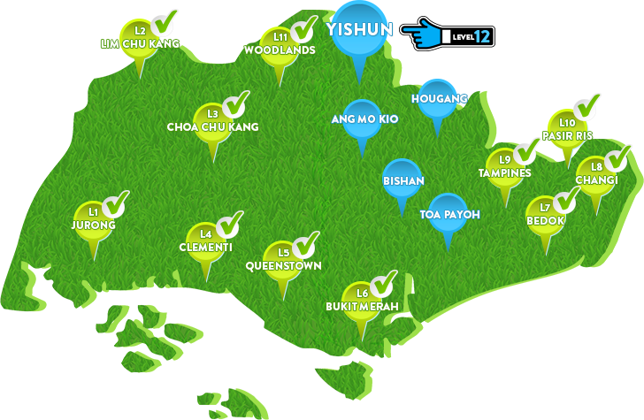

* 1. **Area Type**

**Hawker Centre (HC)**

* Each different level will have a different colored table and chair, ie. HC-Orange; HC-Black; HC-Blue
* This ensures variety within the game for the user, and makes every HC level look different from each other

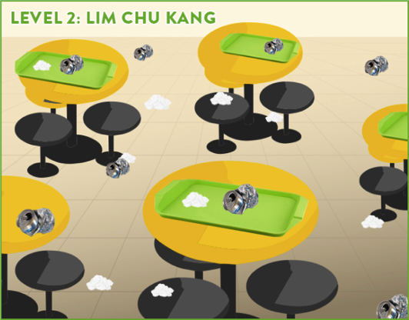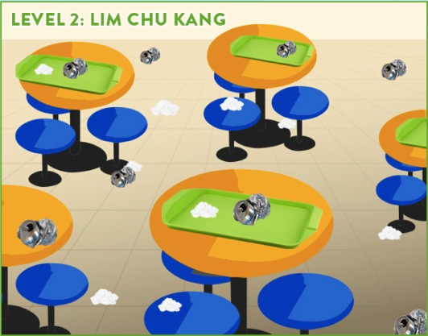

The following levels are HC levels. **(this information is subject to change and should be stored in the database)**

|  |  |  |  |  |
| --- | --- | --- | --- | --- |
| **Level** | **Area** | **Type** | **Trash Pieces** | **Colour Code** |
| 2 | Lim Chu Kang | HC | 11 | HC-Orange |
| 3 | Choa Chu Kang | HC | 12 | HC-Black |
| 6 | Bukit Merah | HC | 15 | HC-Blue |
| 11 | Woodlands | HC | 20 | HC-Orange |
| 13 | Ang Mo Kio | HC | 22 | HC-Black |
| 17 | Hougang | HC | 26 | HC-Blue |

**HDB (H)**

* Each different level will have an updated green road sign with area name. There is no color coding for HDB levels
* This ensures variety within the game for the user

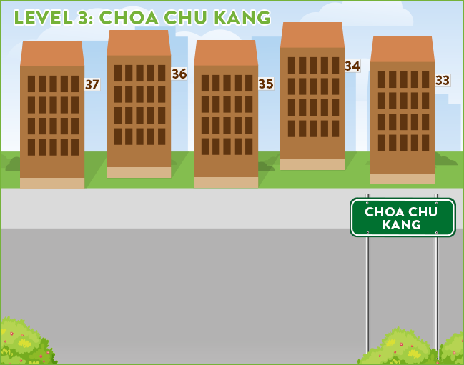 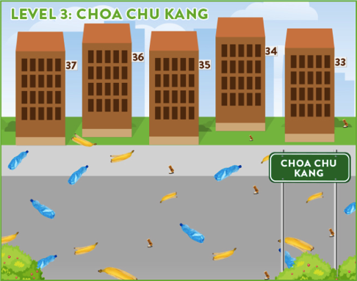

The following levels are H levels. **(this information is subject to change and should be stored in the database)**

|  |  |  |
| --- | --- | --- |
| **Level** | **Area** | **Type** |
| 1 | Jurong | HDB |
| 5 | Queenstown | HDB |
| 7 | Bedok | HDB |
| 9 | Tampines | HDB |
| 12 | Yishun | HDB |
| 15 | Toa Payoh | HDB |

**PARK (P)**

* Each different level will have an updated park sign with area name
* This ensures variety within the game for the user

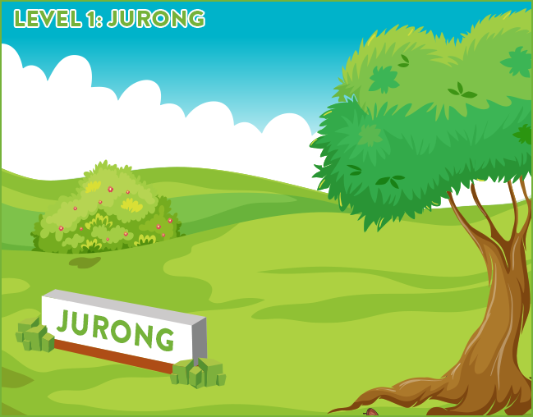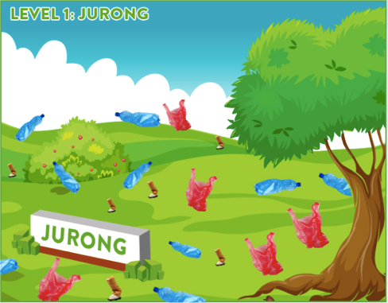

The following levels are P levels. **(this information is subject to change and should be stored in the database)**

|  |  |  |
| --- | --- | --- |
| **Level** | **Area** | **Type** |
| 4 | Clementi | P |
| 8 | Changi | P |
| 10 | Pasir Ris | P |
| 14 | Bishan | P |
| 16 | Seng Kang | P |

**GARDENS BY THE BAY (GBTB)**

* Bonus level is a special park image
* This level is the ONLY one with this image

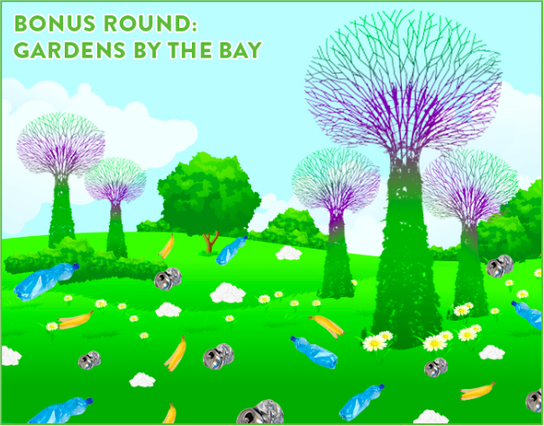

The following levels are P levels.

|  |  |  |
| --- | --- | --- |
| **Level** | **Area** | **Type** |
| 18 | Gardens by the Bay | GBTB |

* 1. **Trash Pieces**

The following trash pieces will be used in the game

|  |  |  |
| --- | --- | --- |
| **Plastic Bottle**  **water-bottle.png** | **Plastic Bag** | **Cigarette But** |
| **Tray** | **Tissue Paper Trash** | **Metal Can** |
| **Banana Peel** |  |  |

The following trash pieces will be used in each area type

|  |  |
| --- | --- |
| **Area type** | **Trash Type** |
| Park | Plastic bottle |
| Plastic bag |
| Cigarette butt |
| HC | Tray |
| Tissue paper trash |
| Metal can |
| HDB | Plastic bottle |
| Banana peel |
| Cigarette butt |
| GARDENS BY THE BAY | All except Tray |

* 1. **Timer Countdown**

Each level has its own timer countdown (number of seconds available to the user to complete the level) as given below:

|  |  |
| --- | --- |
| **Level** | **Timer Countdown (s)** |
| 1 | 10 |
| 2 | 10 |
| 3 | 10 |
| 4 | 11 |
| 5 | 11 |
| 6 | 11 |
| 7 | 12 |
| 8 | 12 |
| 9 | 12 |
| 10 | 13 |
| 11 | 13 |
| 12 | 13 |
| 13 | 14 |
| 14 | 14 |
| 15 | 14 |
| 16 | 15 |
| 17 | 15 |
| 18 | 15 |

1. **FUNCTIONAL REQUIREMENTS**

| **FR#** | **Description** | **Priority** |
| --- | --- | --- |
|  | Pre-like Page | P1 |

Facebook users who are currently not fans of NEA will see this page. They must "like" the page to proceed. Once they like the page, they should be sent to the Landing page (FR2)

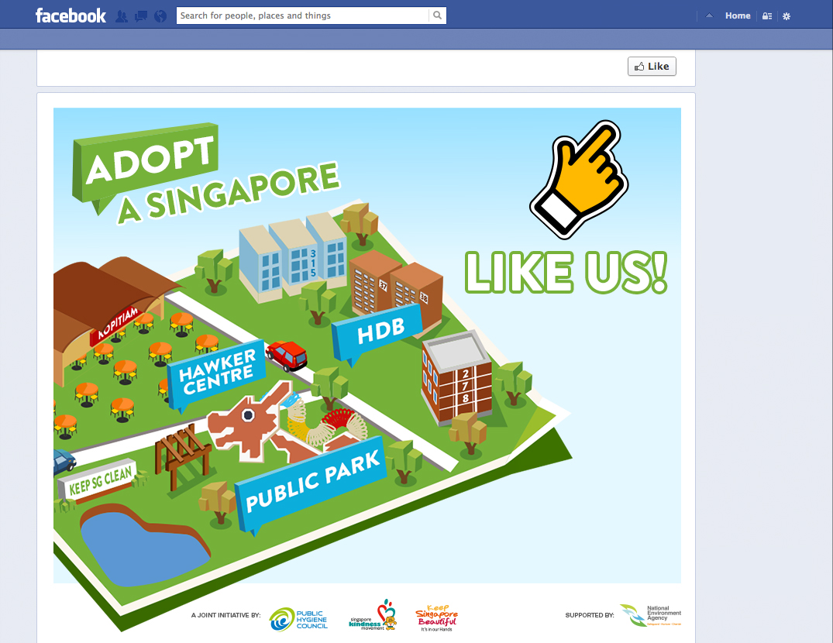

| **FR#** | **Description** | **Priority** |
| --- | --- | --- |
|  | Menu Page | P1 |

Fans of the NEA Page on Facebook should see the page below. This is also the page where visitors who have just liked the page on the pre-like page will land.

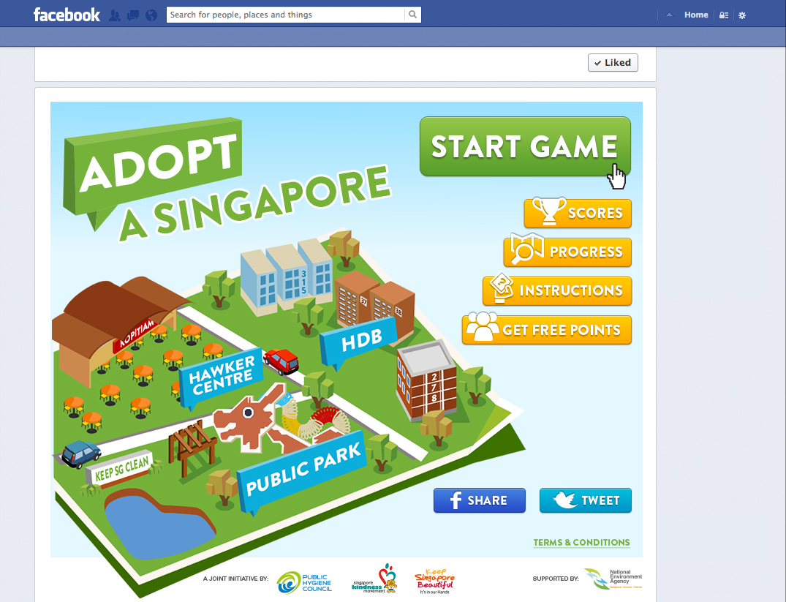

* Start Game --> hyperlinks to FR3
* Scores --> hyperlinks to FR4
* Instructions --> hyperlinks to FR6
* Get Free Points --> hyperlinks to FR7
* Terms and conditions --> hyperlinks to FR2-a
* FB share and Twitter share --> **Jun, need the messages here**
* Logos at the bottom --> **Jun, need logos**

| **FR#** | **Description** | **Priority** |
| --- | --- | --- |
|  | Terms and Conditions Pop-up | P1 |

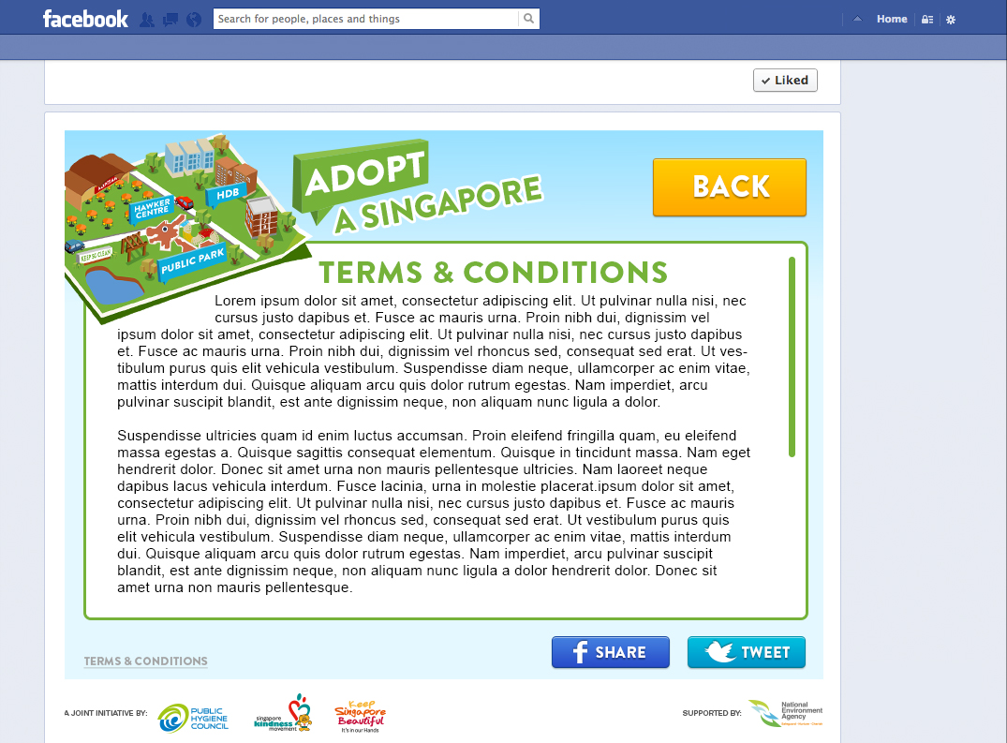

* Back hyperlinks to Menu

| **FR#** | **Description** | **Priority** |
| --- | --- | --- |
|  | START page | P1 |

You get to this page by clicking "Start Game" on the Menu Page (FR2). This is the start page for Level 1

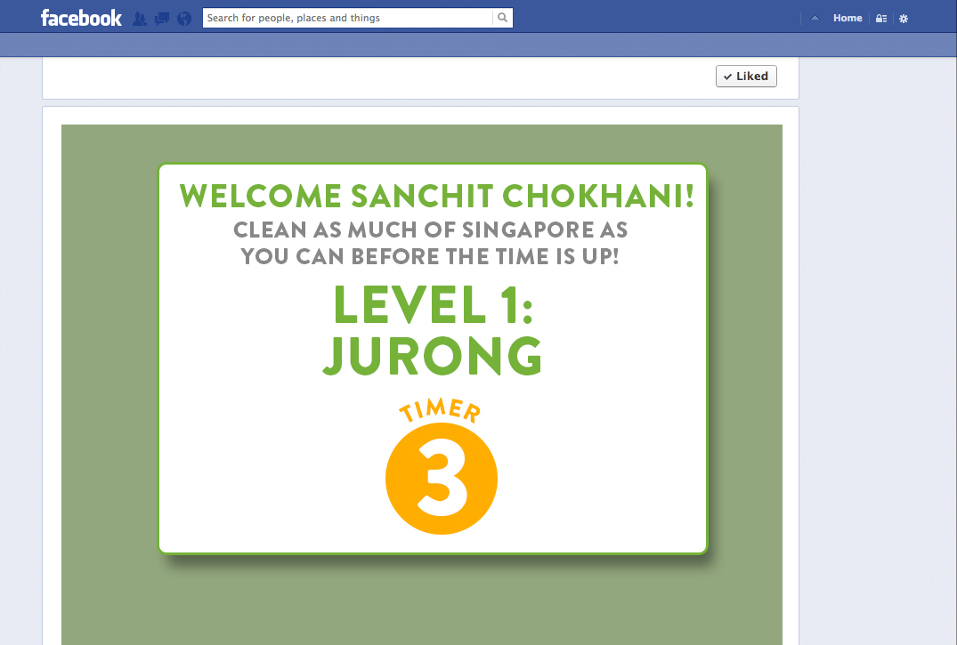

* Show user's full name after Welcome
* Show level number and level name
* Countdown will be 3 seconds and the game starts automatically
* Note that level 1 message is different from all other levels

| **FR#** | **Description** | **Priority** |
| --- | --- | --- |
|  | Game Screens | P1 |

There are 4 types of game screens depending on the level. This is explained in detail in **Section 4.9**

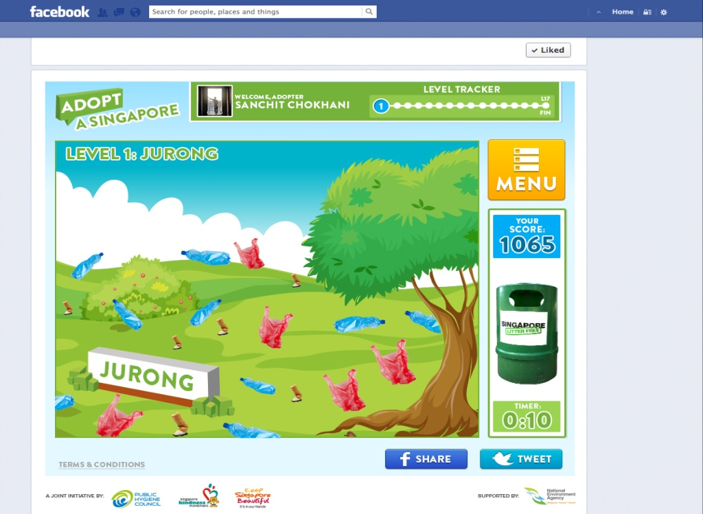

**Functionality required**

* Trash pieces shown in the level should be those corresponding to the area type. **(check Section 4.9 and 4.10)**
* Number of trash pieces should match the requirements **(check Section 4.9 and 4.10)**
* Trash position should be randomized and there should be no overlap between different pieces
* Level Customization should be as per the requirements
  + HDB (H): Green road sign should have the area name
  + Hawker Centre (HC): Orange , Blue or Black themes should be used for table / chair colours
  + Park (P): Park sign should have the area name
  + GDB: Gardens by the bay (bonus level 18) has its unique design which must be used for level 18
* Your Score should show the user's score. This does not change during the level and only updated once the level is completed
* When user clicks on trash it disappears. On the right, an icon of a trash going into the bin is played every time a piece of trash is cleared. (Jun, only visual effect or sound as well?)
* Level Tracker at the top right shows the level the player is currently playing
* On the top left (below Adopt a Singapore), the level number and level name are displayed
* The timer on the right starts at the timer count for that level (which is between 10 and 15 seconds).
* The level completes when the user cleans all trash before the timercount reduces to 0 (level pass) or if the timer reaches 0 before the player has cleared all trash (level fail)
* If the level fails, the player must play the level again and can not go to the next level without clearing the level.

| **FR#** | **Description** | **Priority** |
| --- | --- | --- |
|  | Game Screens: level cleared | P1 |

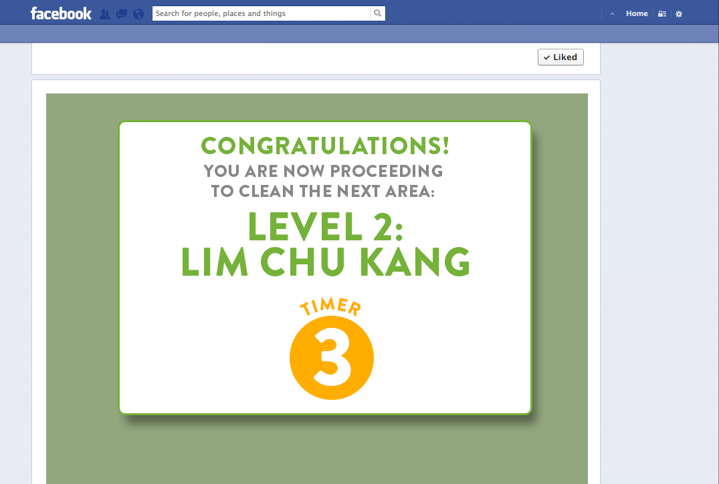

* The timer starts at 3 and goes to 0 at which stage the game screen for next level should load automatically
* The message will show two details: a) Number of the next level and b) Area of the next level

| **FR#** | **Description** | **Priority** |
| --- | --- | --- |
|  | Game Screens: level failed | P1 |

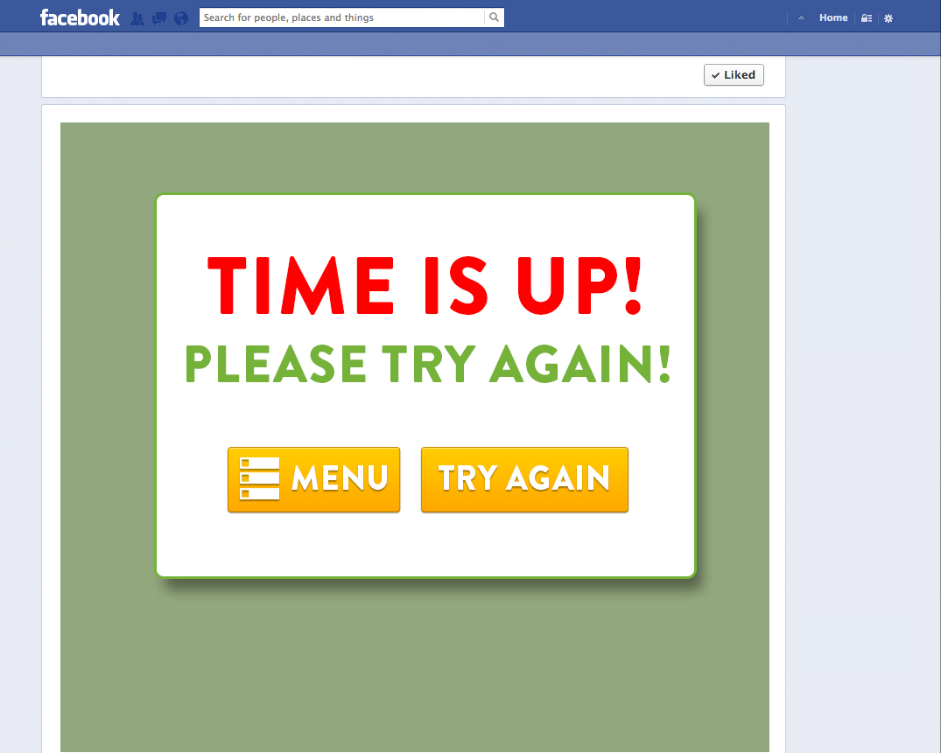

* Try again should take the player back to the same level that they failed

| **FR#** | **Description** | **Priority** |
| --- | --- | --- |
|  | Game Screens: Menu Update | P1 |

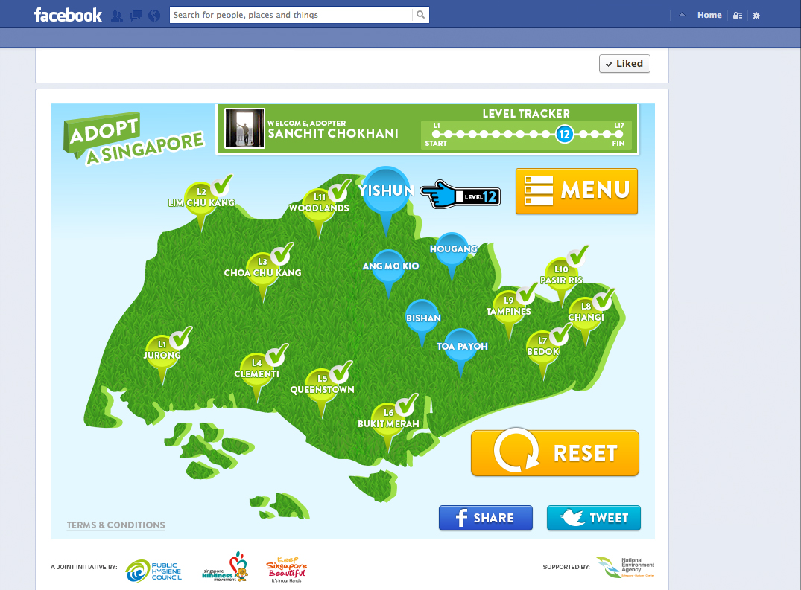

* After each level is passed successfully, the level icon changes to a green pin with a verification tick on top.
* Reset button starts the game at the last level the player had failed. **Jun, Reset is misleading and makes me wonder if I will lose my game progress so far. Can we call this Resume?**

| **FR#** | **Description** | **Priority** |
| --- | --- | --- |
|  | Game Screens: Game Completion (Completion of Level 17) | P1 |

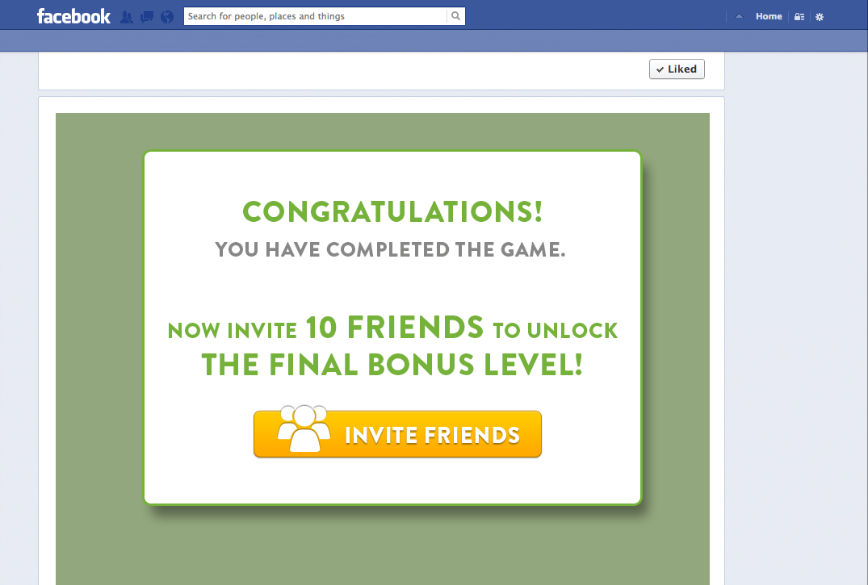

* Once friends are selected successfully and message sent, user is informed that he has unlocked the last BONUS level.

| **FR#** | **Description** | **Priority** |
| --- | --- | --- |
|  | Game Screens: Unlocking Bonus Level | P1 |

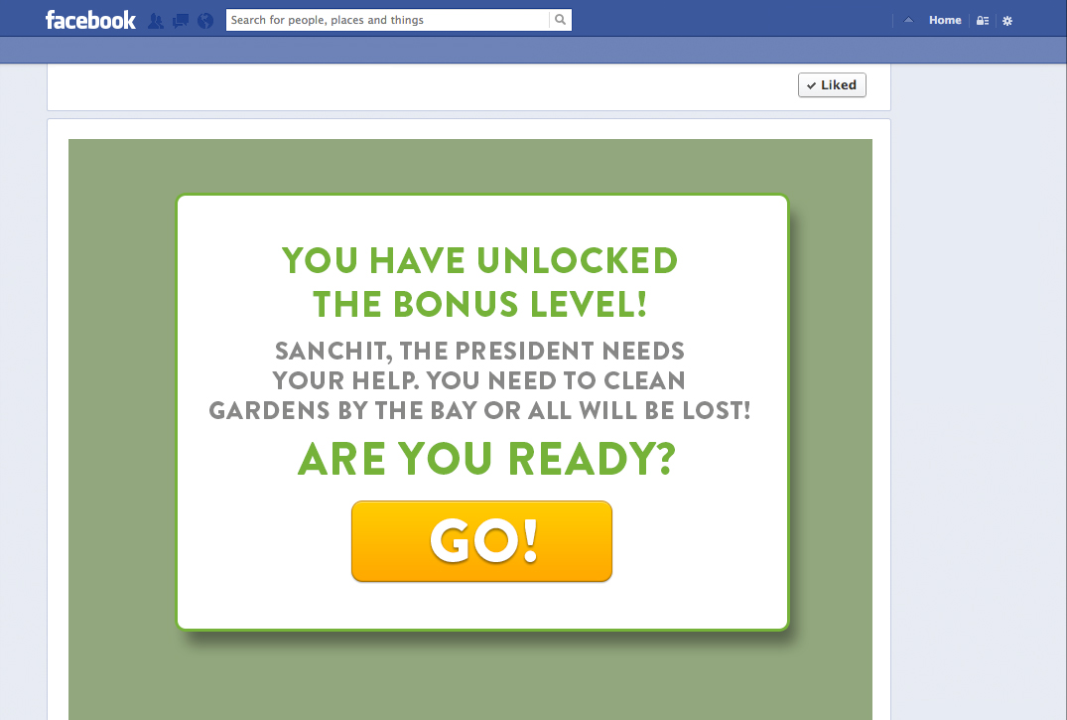

* "Sanchit" in mockup above is user's first name

| **FR#** | **Description** | **Priority** |
| --- | --- | --- |
|  | Game Screens: Level 18 | P1 |

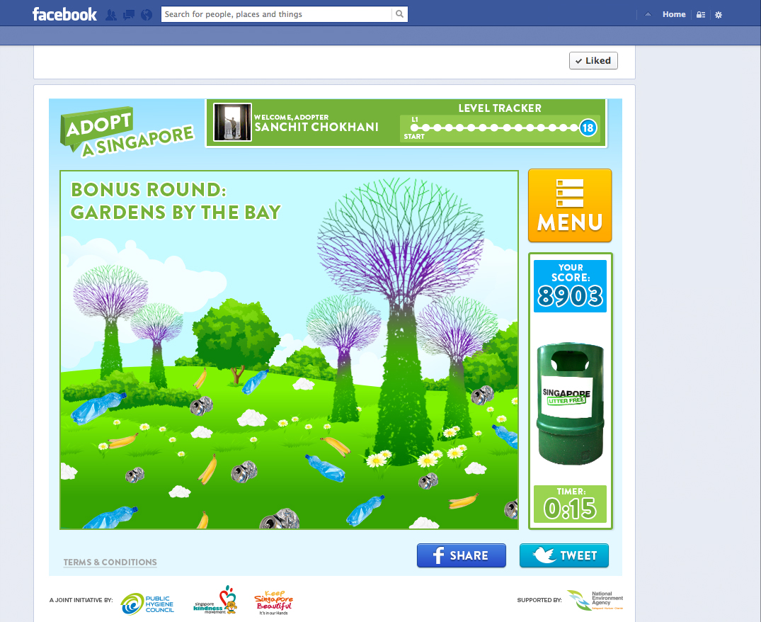

* "Sanchit" in mockup above is user's first name

| **FR#** | **Description** | **Priority** |
| --- | --- | --- |
|  | Game Screens: Level 18 fail | P1 |

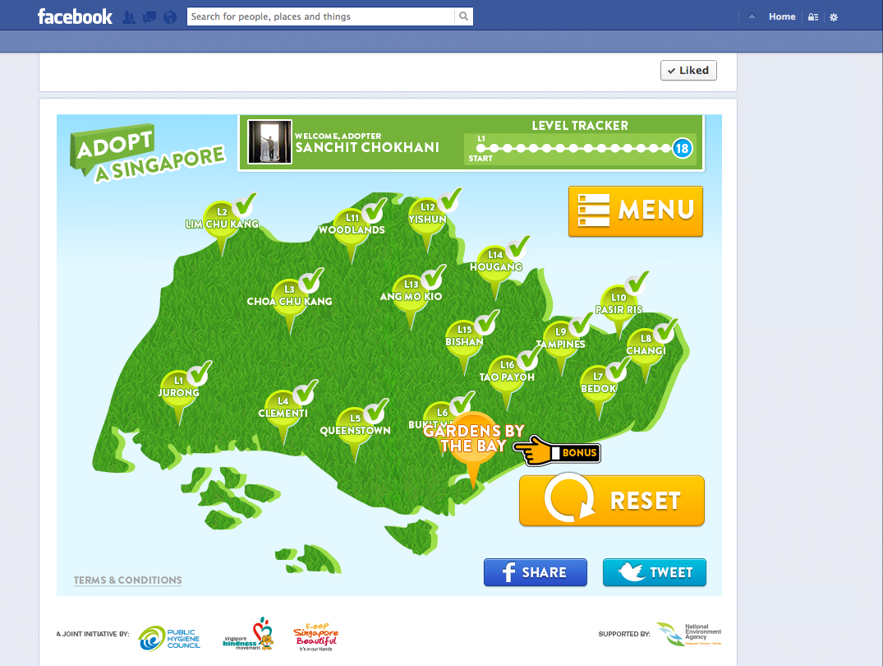

* Level 18 fail should automatically take the player back to the menu

**Jun**, enough thought has not been given here. If level 18 fails, the player should see FR4-b. If they click on menu, they can be redirected to the image above or they could click on "try again" and play the game again

| **FR#** | **Description** | **Priority** |
| --- | --- | --- |
|  | Game Screens: Level 18 Success | P1 |

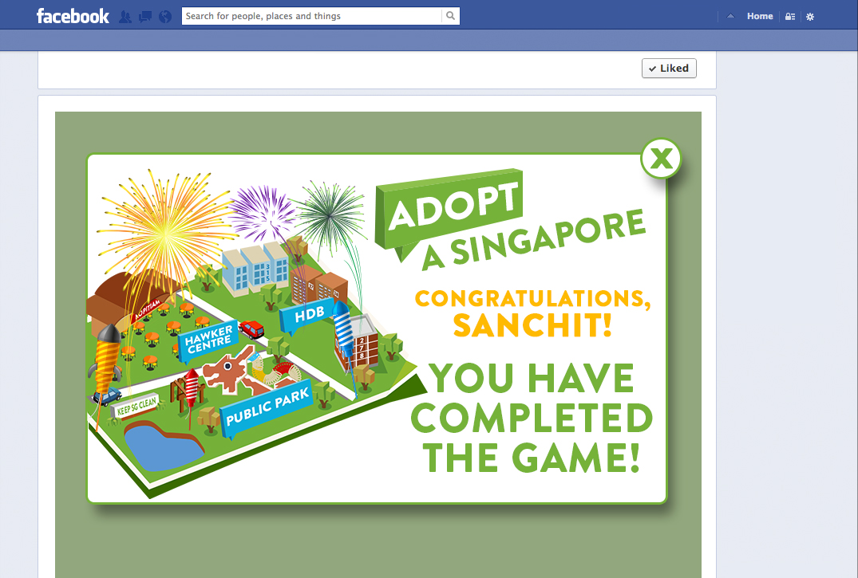

| **FR#** | **Description** | **Priority** |
| --- | --- | --- |
|  | Game Screens: Menu Screen after completing Level 18 | P1 |



Jun. this can actually be called Reset as the scores will be reset

Clicking Reset show the screen below

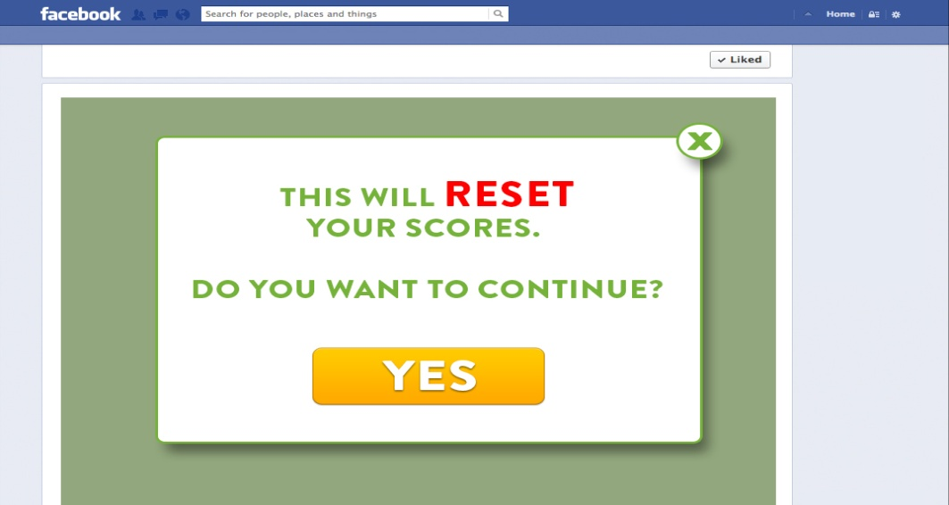

* When user clicks YES, his points will be reset to ZERO and all memory of his levels will be erased

| **FR#** | **Description** | **Priority** |
| --- | --- | --- |
|  | Scores | P1 |

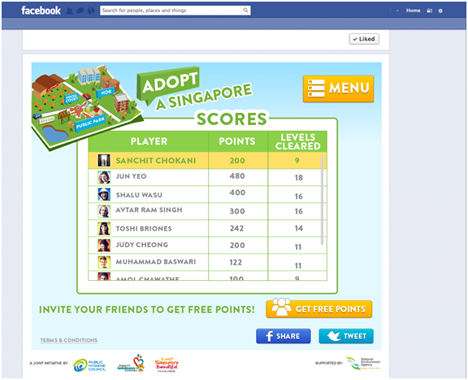

* Users are sorted by POINTS, not Levels Cleared
* User will always show on the top (first row) for them to keep track of their scores
* User’s name and profile pictures to show in leaderboard
* Get Free Points should go to FR7

| **FR#** | **Description** | **Priority** |
| --- | --- | --- |
|  | Progress (Map Dashboard) | P1 |



* Completed levels should show a green pin with a verification tick on top
* Levels not yet completed are shown in Blue
* Current level has a hand with the finger pointing to the area
* RESET button starts the game at the last level he had failed
* After user ‘loses’ a level, he lands by default on the Dashboard, and is updated about the last level he had failed at
* Level tracker shows the current level
* Facebook Share and Tweet buttons should share or tweet a message  **(Jun, image + copy to be provided)**

| **FR#** | **Description** | **Priority** |
| --- | --- | --- |
|  | Instructions | P1 |

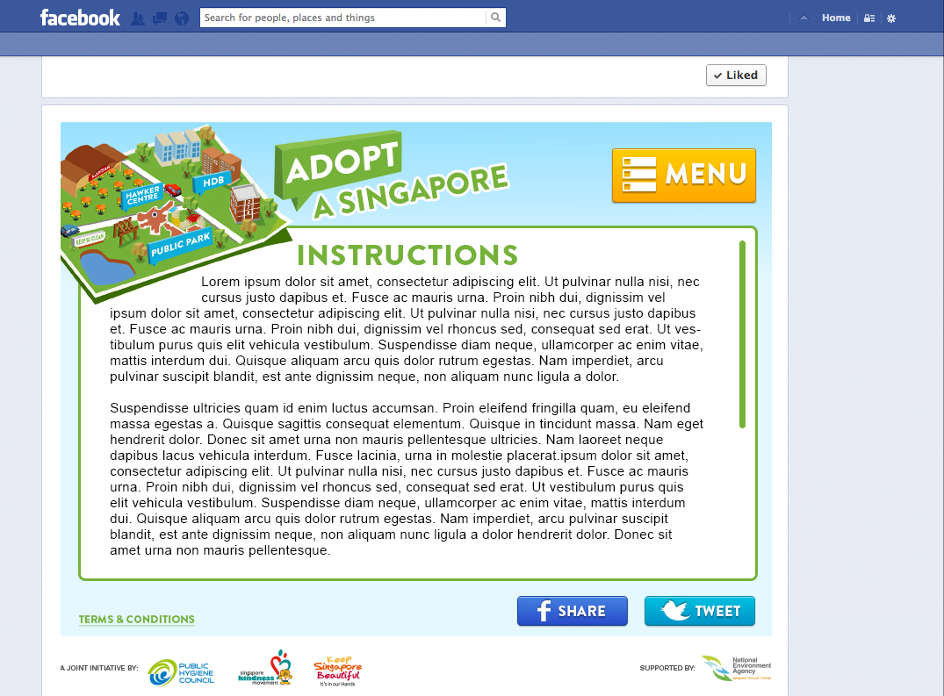

Menu should hyperlink to Menu (FR2)

There is an internal scroll to read all instructions

**Jun, need a copy of the instructions**

| **FR#** | **Description** | **Priority** |
| --- | --- | --- |
|  | Get Free Points | P1 |

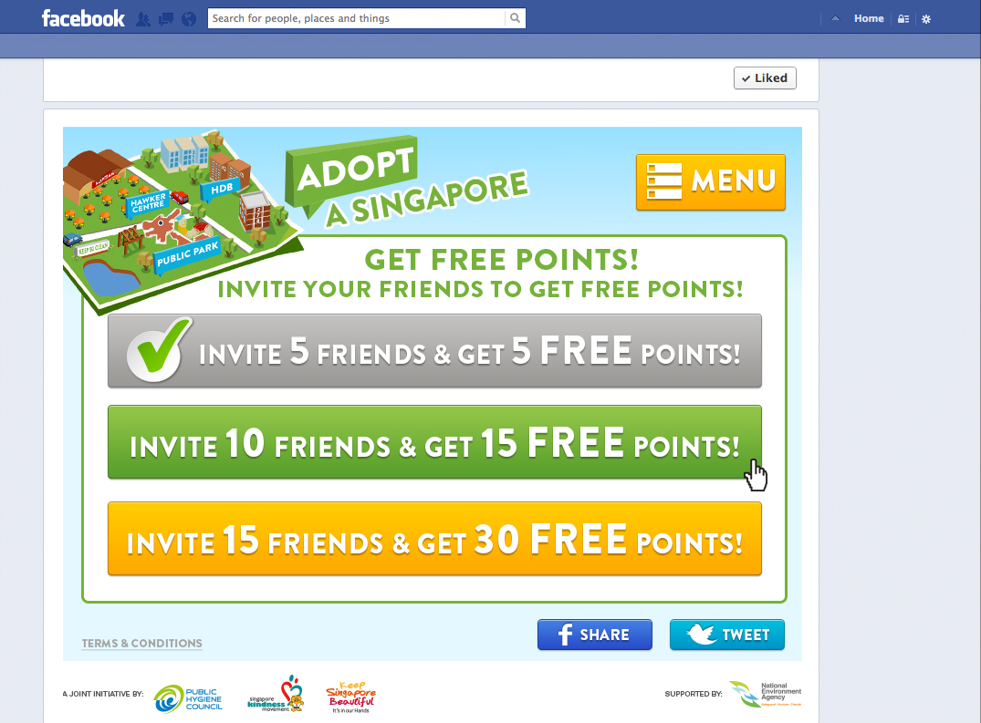

* Tab colour should be orange by default
* Tab colour should be green on mouseover
* Tab colour is grey when user has clicked and referred friends

| **FR#** | **Description** | **Priority** |
| --- | --- | --- |
|  | Get Free Points: Pop-up | P1 |

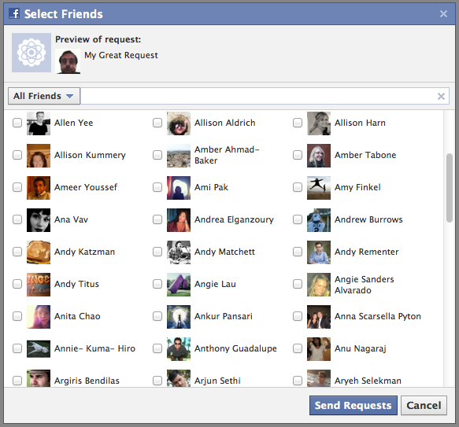

Note: It is not possible to restrict the number of friends to 5 or 10 or 15 in the facebook popup.

**Amol, please can you check if there is a way out?**

| **FR#** | **Description** | **Priority** |
| --- | --- | --- |
|  | Get Free Points: Thank you Pop-up | P1 |

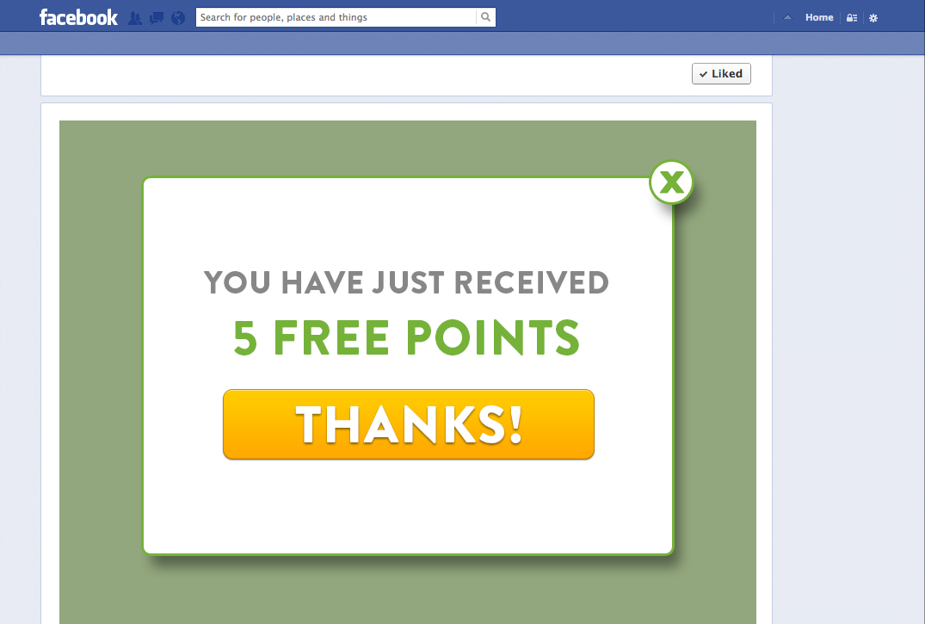

* "5" is dynamic and should be replaced with the actual number of friends referred.
* Points should be updated in the database immediately

| **FR#** | **Description** | **Priority** |
| --- | --- | --- |
|  | Admin Reports | P1 |

| **FR#** | **Description** | **Priority** |
| --- | --- | --- |
|  | Admin Reports - Edit Instructions | P1 |

Admin panel to edit instructions

| **FR#** | **Description** | **Priority** |
| --- | --- | --- |
|  | Admin Reports - Edit Facebook Message | P1 |

* Headline Copy (Client must have the ability to customize this from backend admin panel)
* Body Copy (Client must have the ability to customize this from backend admin panel)
* Icon (Client must have the ability to customize this from backend admin panel. Size is 90x90 px)

1. **OTHER REQUIREMENTS**
   1. Migration Requirements

This is a new project. There are no migration requirements

* 1. Security Requirements

No specific security requirements.

* 1. Performance /Traffic and Technical Requirements
     + The app should be able to handle X concurrent users and a total **of Y users** during the campaign period.
     + The Server uptime needs to be in excess of 99.9%
  2. Monitoring and Support Requirements

Support for 1 week post-deployment

* 1. Reporting Requirements

The client needs to know engagement metrics on a weekly basis (FR7-a)

* 1. Admin Tool Requirements

Admin tool requirements have been detailed in FR7

* 1. Internationalization requirements

There are no internationalization requirements

* 1. Further Platform Requirements

The app needs to work on the PC as well as mobile

* 1. External Messaging Requirements

Facebook Messaging requirements have already been highlighted in the functional requirements. There are no other external messaging requirements

* 1. Workflow, Timelines And Milestones

Please check Project SGX in the Project Management Tool at projectmanager.com for further details. Important dates are given below

|  |  |
| --- | --- |
|  |  |
| **ITEM DESCRIPTION** | **Dates** |
| **FACEBOOK APP PHASE 2** |  |
| Designs for Facebook App Web & Mobile | Jun 17 - Jul 3 |
| Internal Review of Designs and Feedback | Jul 3 - Jul 4 |
| Revisions based on Internal Review | Jul 4 - Jul 9 |
| Client Review of Designs & Feedback | Jul 10 - Jul 12 |
| Revisions based on Client Review | Jul 15 - Jul 18 |
| Final check and Design Sign-off | Jul 19 |
| Development of Facebook Web and Mobile applications | Jul 22 - Aug 7 |
| National Holiday | Aug 8 - Aug 11 |
| Deployment of Web App on Staging | 'Aug 12 |
| Internal UAT of Web App on Staging | 'Aug 13 |
| Minor tweaks and changes to web app 1 | Aug 14 - Aug 15 |
| Deployment of Mobile App on Staging | 'Aug 13 |
| Internal UAT of Mobile App on Staging | 'Aug 14 |
| Minor tweaks and changes to mobile app 1 | Aug 15 - Aug 16 |
| Client UAT of Web App on Staging 1 | 'Aug 19 |
| Client UAT of Mobile App on Staging 1 | 'Aug 19 |
| Minor tweaks and changes to web and mobile app based on client feedback 2 | Aug 19 - Aug 20 |
| Client UAT of Web and Mobile App on Staging 2 | 'Aug 21 |
| Minor tweaks and changes to both apps on staging 3 | 'Aug 22 |
| **Deployment of the FB web and mobile app to LIVE** | **'Aug 23** |
| **Sign Off** | **Sep 2** |
|  |  |
|  |  |

1. **COMMUNICATION CHECKLIST**

Affected / Information groups will get informed at spec submission / Beta version. They will also need to sign-off before go-live

|  |  |  |  |
| --- | --- | --- | --- |
| **Group** | **Stakeholders** | **Status** | **Comments** |
| Product / Project Management | Amol |  |  |
| Execs / Vertical Project Sponsors | Shalu, Ram |  |  |
| Sales and Business Development | Jun |  |  |
| PR and Marketing | None |  |  |
| Deployment | Amol |  |  |
| Network / Bandwidth / Security | Amol |  |  |
| Tech, Delivery (Developers) – Spec Briefing | **Developer Name** |  |  |
| Design | Toshi |  |  |
| QA | Sev |  |  |

1. **TEST CASES**

|  |  |
| --- | --- |
| **Test Case ID:** | **Test Designed by:** |
| **Test Priority:** | **Test Designed Date:** |
| **Module Name:** | **Test Executed by:** |
| **Test Title:** | **Test Execution Date:** |
| **Description:** | |
| **Browser:** | **Operating System:** |
| **Preconditions:** | |
| **Dependencies:** | |

|  |  |  |  |  |  |
| --- | --- | --- | --- | --- | --- |
| **Step** | **Test Steps** | **Expected Results** | **Actual Result** | **Status**  **(Pass/ Fail)** | **Notes** |
| **1** |  |  |  |  |  |
| **2** |  |  |  |  |  |
| **3** |  |  |  |  |  |
| **4** |  |  |  |  |  |
| **5** |  |  |  |  |  |
| **6** |  |  |  |  |  |
| **7** |  |  |  |  |  |
| **8** |  |  |  |  |  |
| **9** |  |  |  |  |  |
| **10** |  |  |  |  |  |